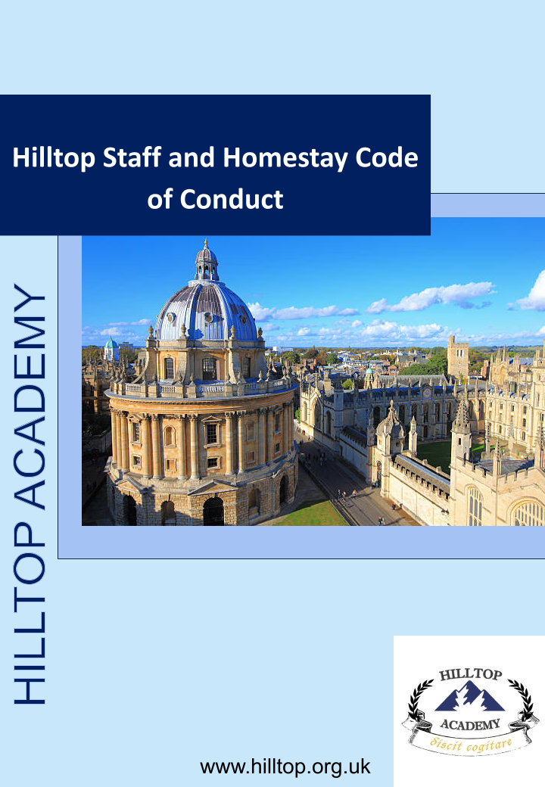

Contents
Power and positions of trust 3
Duty of care to children and young people 4
Exercising professional judgement 4
Use of appropriate language 4
Sexual contact with young people 4
Communication with Students 4
Social contact with Students 4
Social contact with Parents / Agents / staff at partner schools 4
Physical contact 4
An outright ban on any corporal punishment 5
Care of distressed Students 5
One-to-one meetings 5
Students’ entitlement to privacy 5
Transporting Students 5
Gifts and rewards 5
Use of photographs and videos 6
Searching Students and their belongings 6
Allegations against a member of staff or homestay 6
Low Level Concerns 7
Whistleblowing 7
Review 7

Hilltop Staff/Homestay Code of Conduct
Statement

The following code of conduct for staff and homestays gives clear guidance on behaviour that Hilltop expects from all members of staff and homestays working within the organisation. These guidelines confirm and reinforce the professional responsibilities of all staff and homestays. They help adults establish safe practices and reduce the risk of false accusations or improper conduct. Staff are required to self-report to Aegis any safeguarding concerns or situations that could be compromising or misconstrued, or where behaviour has fallen below expected standards.

Code of Conduct

Power and positions of trust
In your role as a member of staff or homestay, you will have power over students and will hold a position of trust. It is imperative that these are not abused in any way. Hilltop staff and homestays should be aware of their own conduct and ensure that their professional practice is clear and unambiguous. Staff should ensure that they work in an open and transparent way, not showing favouritism and by treating students respectfully and fairly irrespective of culture, disability, gender, language, racial origin, religious belief and sexual orientation.

Duty of care to children and young people
All staff, volunteers and homestays have a duty of care to children and young people. As such they must adhere to the various policies, including the safeguarding and child protection policy that outline how we safeguard students in our care.

Exercising professional judgement
Hilltop recognises that this guidance may not cover every eventuality. There may be times when staff use their professional judgement to deal with situations not outlined in this section. In such circumstances staff should always advise their senior colleagues of the justification for any action taken or proposed.

Use of appropriate language
It is important to remember that whilst undertaking your role, you are representing Hilltop. We expect all staff and homestays to be polite and courteous whilst undertaking their duties. It is inappropriate to swear or use abusive language.

Sexual contact with young people
Any (contact or non-contact activity) sexual behaviour (including grooming of a child so sexual abuse can take place), by a member of staff or homestay with or towards a student is unacceptable and could be a matter for criminal and/or disciplinary proceedings. Students are protected by the same laws as adults in relation to non-consensual sexual behaviour, and by additional legal provisions depending on their age and understanding.

Communication with Students
Communication with students should only be in a professional capacity, using appropriate language and tone. Any communication, for example via telephone or WeChat should be via a guardianship organisation device.

Social contact with Students
Staff members should not give their personal contact details to students for example email address, home or mobile telephone numbers or details of web based identities. If students locate these by any other means and attempt to contact or correspond with the staff member, they (staff member) should not respond and must report the matter to their line manager. Students and staff should communicate for professional reasons using the company email addresses and telephone numbers. It is inappropriate for staff or homestays to befriend students and mix with them socially as a friend.

Social contact with Parents / Agents / staff at partner schools
As for students, it is inappropriate for guardianship organisation staff or homestays to befriend parents, agents or school staff on social media (unless they were previously friends). Hilltop expects any contact that staff or homestays have with parents, agents and staff at partner schools to be courteous and polite as the individual is representing the organisation. It is inappropriate for staff or homestays to befriend parents, agents or staff at partner schools and mix with them socially as a friend unless of course they were previously friends before working with them.

Physical contact
Guardianship organisation staff or homestay family members are advised to avoid physical contact with students as even when well intentioned, this contact may be misconstrued by the student, an observer or any person to whom this action is described. There may also be cultural, gender sensitive or religious reasons about touching which the homestay member is not aware of. Guardianship organisation staff and homestay family members must be aware that any physical contact with a student may need to be explained and would be open to scrutiny. Homestays and staff may only use reasonable, appropriate and lawful means of control to maintain safety.

An outright ban on any corporal punishment
It is illegal to use corporal (physical) punishment. Any reported incidences of corporal punishment will be reported by Hilltop to the police.

Care of distressed Students
When a student is upset or distressed (for example due to homesickness) remember that sympathy and help can be given using kind words. Also, sitting with the student and listening to them until they feel better can also be of great comfort. Staff and homestays should, therefore, use their professional judgement at all times and in cases where this may be unavoidable (for example a young child who has fallen over, makes physical contact with the primary carer first, or is crying with homesickness), we would recommend asking a child if physical comfort is wanted before giving it. However in the majority of cases it would not be appropriate and we do not recommend physical contact, and would encourage comforting the child as detailed above.

One-to-one meetings
Members of staff and homestays should be mindful when meeting students on a one-to-one basis. Staff meeting students should do so in a public space, such as a school classroom, meeting room or common room. If meeting students outside of school the meetings should take place in a public area such as a coffee shop. In the homestay environment, homestays and their families should avoid going into the student’s bedroom or inviting them into their bedroom.

Students’ entitlement to privacy
Guardianship organisation staff and homestays must respect student’s right to privacy. That means not entering their bedrooms (unless the homestay is required to clean the room, and this should only be undertaken with prior warning and when the student is not in the room), ensuring that bathrooms have suitably locks and respecting the student’s right to retreat to their rooms or a quiet area in the home if they feel the need. When students wish to email or call home, they should be allowed to do so in privacy.

Transporting Students
Staff may at times be expected to transport students, for example to the airport, homestay, school or other out of school activities. A log of these journeys should be recorded. Any cars used must meet all legal requirements (e.g. MOT and insurance). Students should travel in the back of the vehicle and must wear seatbelts. Booster seats should be used where required. Homestays transporting students should do so in line with the guidance included in the Homestay Handbook.

Gifts and rewards
Hilltop staff and homestays should not give gifts to students on a regular basis and should not give gifts of any significant value. Similarly, such gifts should not be given to the families of students as this could be interpreted as a gesture to groom or bribe a student. Where a reward is given to a student, this should be in accordance with agreed practice, consistent with the behaviour policy and not based on favouritism. On no account should any monetary gifts be given.

There may be occasions where students or their families may want to present you with a gift, for example as a thank you. You can accept gifts (not monetary) and hospitality, which are small gestures and are of low value. Any gift or hospitality which is more than just a token, defined as having a large value should be politely refused or returned.

Use of photographs and videos
Staff should ensure that any photography, videos or images of students are taken with their and their parent’s consent and that these are only published where such consent has been obtained. Images should be securely stored and used only by those authorised to do so. Under no circumstances should images be taken of students without consent or without the students knowing that the images are being taken. Staff and homestays should always be able to justify images of students in their possession and avoid taking images in one to one situations.

Searching Students and their belongings
It may be necessary in certain circumstances to search students and belongings. This may be due to suspected possession of a prohibited item. This includes:
  - knives or weapons;
  - alcohol;
  - illegal drugs;
  - stolen items;
  - tobacco and cigarette papers;
  - fireworks;
  - pornographic images;
  - any article that a member of staff or homestay reasonably suspects has been, or is likely to be, used to commit an offence or injure a person or damage property.
Consent should be sought from the student, although a search may still be conducted if consent is not received. It is important that such a search is handled sensitively. Homestays should contact Hilltop who will attend the house to undertake the search, unless it is felt that a delay may put individuals at risk. Wherever possible, the search should be conducted by a member of Hilltop staff of the same gender as the student. The search should be conducted with the room door open and with a witness and the student present. If a search is conducted on students, please be aware that only outer clothing (not worn next to the skin or immediately over a garment being worn as underwear) may be removed. Staff cannot carry out an intimate search; this can only be carried out by the police. A full incident report must be completed and parents informed.

Allegations against a member of staff or homestay
Where it is alleged that anyone working, volunteering or hosting students for Hilltop has:
• behaved in a way that has harmed a child, or may have harmed a child; and/or
• possibly committed a criminal offence against or related to a child; and/or
• behaved towards a child or children in a way that indicates he or she may pose a risk of harm to children; and/or
• behaved or may have behaved in a way that indicates they may not be suitable to work with children (known as transferable risk)
Hilltop will deal with allegations in accordance with the procedure set out in the Safeguarding and Child Protection Policy.

Low Level Concerns
The term ‘low-level’ concern does not mean that it is insignificant, it means that the behaviour towards a child does not meet the harms threshold set out in our safeguarding policy. A low-level concern is any concern – no matter how small, and even if no more than causing a sense of unease or a ‘nagging doubt’ - that an adult working for or on behalf of the guardianship organisation may have acted in a way that:
• is inconsistent with the staff code of conduct, including inappropriate conduct outside of work, and
• does not meet the allegations threshold or is otherwise not considered serious enough to consider a referral to the LADO.
Examples of such behaviour could include, but are not limited to:
• being over friendly with children;
• having favourites;
• taking photographs of children on their mobile phone;
• engaging with a child on a one-to-one basis in a secluded area or behind a closed door; or,
• using inappropriate sexualised, intimidating or offensive language.
Such behaviour can exist on a wide spectrum, from the inadvertent or thoughtless, or behaviour that may look to be inappropriate, but might not be in specific circumstances, through to that which is ultimately intended to enable abuse. Hilltop has a Low-Level Concerns policy that outlines the processes followed in the event of a concern being identified.

Whistleblowing
The Hilltop Whistleblowing Policy provides guidance to staff on how to deal with malpractice in the workplace where there is concern for the safety of children.

Review
We are committed to reviewing our policy and good practice annually.
This policy was last reviewed on: 03/06/2026
Signed: …………………………………………………………………………
Date: 03/06/2026

