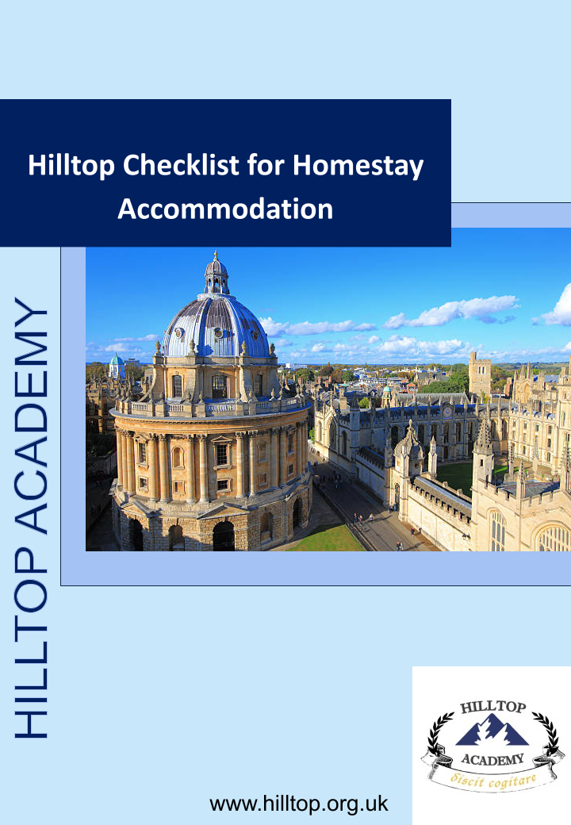

Contents
Name of Homestay: 3
Name of member of staff checking accommodation: 3
Date: 3
Documents to see/ discuss 3
Accommodation Checks 4
Risk Assessment 5
Health and safety checks 6
Care provision 7
Training 8
Check of Safeguarding Understanding 8
Additional comments 9

Hilltop Checklist for Homestay Accommodation

Name of Homestay: Bin Hu

Name of member of staff checking accommodation: Jing Wang

Date: 03/06/2026

Documents to see/ discuss
Requirement |  | Y | N |  | N/A | Comments
Copies of ID (when required e.g. first visit, for new DBS check) |  | X
Landlord gas safety check (retain a copy for homestay records) |  | X
Home insurance - explain AEGIS requirements |  | X
Car insurance - explain AEGIS requirements |  | X
Requirement | Homestay Member  [Aged 16 and over]  Name |  |  | DBS certificate number |  |  | Comments
Original DBS for all relevant members of the homestay | Bin Hu |  |  | 001964513631 |  |  | Father
Original DBS for all relevant members of the homestay | Haiyan Ge |  |  | 001964513229 |  |  | Mother
Original DBS for all relevant members of the homestay | Jianing Hu |  |  | 001964513405 |  |  | Son

Accommodation Checks
Requirement | Y | N | N/A | Comments
Is the homestay a non-smoking environment? | X
Are there any pets in the household? If so, please provide details in the comments box. |  | X
View bedroom/s  (Provide details of accommodation and suitability in comments box) |  |  |  | 4 double bedrooms, all with windows and doors that lock.
Is there appropriate hanging and drawer space for clothing? | X
Is there a private space to study with a suitable desk, chair and lamp? | X
Check that social area(s) provided are well kept, clean and in good repair, with sufficient natural light. | X
Suitable heating and lighting? | X
Is there access to sufficient supplies of hot water as required? | X
Do students have access to a bathroom with a lock on the door and either a shower or bath? | X
Is there any CCTV at the property? If so, discuss the need (is it clear and lawful?). Is suitable privacy ensured for students? Ask homestay to provide paper trail to show how they are adhering to ICO guidelines. |  | X
Inform/ remind the homestay:  - That suitable safeguards must be in place to ensure that students have sufficient privacy from other students. (Parents should be made aware of Students who may wish to share bedrooms and must give consent before the arrangement goes ahead.)  - Where homestays are using a double bed, only one student is using this facility. Under no circumstances must students share a double bed.  - Homestays who work with other GOs are not accommodating more than three students in total when members of an AEGIS GO are being hosted.  - When students under the age of 16 are in the care of a homestay, no students over the age of 20 are being hosted either by the GO or another GO working within the same homestay.  - That homestays do not host any other paying guests or operate any form of bed and breakfast facility when hosting AEGIS Students. | X |  |  | RA included below, completed by Jing Wang.

Risk Assessment
Requirement | Y | N | N/A | Comments
Has the homestay completed a risk assessment for the accommodation (in addition to the checks below)? If not, member of staff to complete during visit. [Retain a copy of the RA to put on file] | X

Health and safety checks
Requirement | Y | N | N/A | Comments
Has the homestay completed a risk assessment for the accommodation? If not member of staff to complete during visit. [Using separate RA template] |  |  | X
Smoke alarms on every storey (ask homestay to confirm that they are working). | X
Carbon monoxide alarms in any room containing a gas, liquid or solid fuel burning appliance (ask homestay to confirm that they are working). | X
Visual check of electrical safety. | X
Check that the homestay has suitable fire evacuation procedures and that these have/will be discussed with student. | X
If fire extinguishers and fire blankets are provided check that they have been suitably serviced. | X
Where open fires are used, check that a suitable fire guard will be in place when the fire is lit. | X
Check that any matches or lighters are appropriately stored. | X
A basic first aid kit should be available to include, plasters, sterile eye-pad, triangular bandage, safety pins, non-medicated wound dressing, disposable gloves, leaflet giving guidance on first aid. | X
Check that any prescription medication and drugs are kept safely. | X
Alcohol should be appropriately stored. | X
Check that the homestay has an awareness of basic food hygiene when preparing meals for students. | X

Care provision
Requirement | Y | N | N/A | Comments
Meals: Check that the homestays will cater for full board provision of breakfast, lunch and dinner during the students stay, taking account of any dietary needs. | X
Meals: Check that the homestays will provide students with access to suitable drinks and snacks during their stay. | X
Meals: Check that where a homestay allows a student to prepare meals for themselves, appropriate supervision is provided in line with their age and experience and that basic food hygiene controls are in place. | X
Laundry: are there suitable laundry facilities for students who are resident for more than one night? | X
Supervision: Discuss supervision and NPSCC advice. Ensure that:  - Students aged 12 and under are not to be left home alone for a long period of time  - Students aged 16 and under are not to be left alone overnight and  - Students are not left home alone regardless of their age if they do not feel comfortable with this. | X
Online safety: Discuss policy implementation- guidance on internet use and monitoring. | X

Training
Subject | Y | N | N/A | Record of what was discussed
Induction (new homestays):  Contact details of key staff at the GO given  All policies, documents and procedures given and explained?  Handbook given and explained? | X
 | X
 | X
 | X
Safeguarding training- copy of certificate provided for records | X
Safeguarding updates (at least annually) | X
Annual update training (general) | X
Provision and discussion of updated policies and handbooks | X

Check of Safeguarding Understanding
Question | Response
- Why do you want to become a homestay? [Probe their motivation for taking on the role] | I am a teacher and it is much easier for my students to attend our lessons during holiday time. It brings in company for my son who is an only child.
- What were the key points you learnt from the safeguarding training you completed? | The signs to recognize abuse/trouble at school and especially online bullying which can be harder to spot the signs for. Also the importance of reporting concerns and maintaining boundaries.
- If you had any safeguarding concerns, do you know who you need to contact?  Who could you turn to if you either could not get hold of our DSL or did not feel your concern was taken seriously? | Yes, Jing Wang the DSL or Wenjie Chen the DDSL.

Additional comments
Issue | Action required and by whom | Complete?

Homestay Accommodation Risk Assessment
Host Family Name: Bin Hu
Address: 52 Forbes Avenue, Heyford Park, Bicester, OX25 5DG
Assessment Date: 01/06/2025
Assessor: Jing Wang
Review Date: 03/06/2026

Property Safety
Hazard | Risk | Controls in Place | Risk Rating
Fire | Injury or death | Working smoke alarms, escape routes explained, fire blanket/extinguisher where appropriate | Low
Carbon Monoxide | Poisoning | CO alarm installed near fuel-burning appliances | Low
Electrical Safety | Injury | No exposed wiring, appliances in good condition | Low
Gas Appliances | Injury | Appropriate servicing and maintenance | Low

Student Accommodation
Hazard | Risk | Controls in Place | Risk Rating
Inadequate bedroom | Welfare concerns | Private bedroom with suitable furnishings | Low
Lack of privacy | Welfare concerns | Bedroom door, privacy respected | Low
Unsuitable study facilities | Educational impact | Desk or suitable study area available | Low

Safeguarding
Hazard | Risk | Controls in Place | Risk Rating
Unsupervised contact with unsuitable adults | Safeguarding risk | DBS checks completed where required | Low
Unknown household members | Safeguarding risk | All residents declared and assessed | Low
Inappropriate boundaries | Safeguarding risk | Host family safeguarding training and guidance provided | Low

Health and Welfare
Hazard | Risk | Controls in Place | Risk Rating
Unsafe food storage | Illness | Kitchen hygienic and maintained | Low
Pets | Allergy or injury | Pet risks assessed and disclosed | Low
Smoking/Vaping | Health risk | Policy communicated and assessed | Low

Online Safety
Hazard | Risk | Controls in Place | Risk Rating
Inappropriate internet access | Safeguarding concerns | Internet supervision guidance provided | Low
Online exploitation | Welfare concerns | Host family aware of reporting procedures | Low

Transport and Location
Hazard | Risk | Controls in Place | Risk Rating
Unsafe route to school | Injury | Route assessed and explained | Low
Remote location | Delayed response in emergency | Emergency contacts available | Low

Mental Health and Welfare Support
Hazard | Risk | Controls in Place | Risk Rating
Student emotional distress | Welfare concerns | Host understands reporting and escalation procedures | Low
Mental health crisis | Harm to student | Emergency procedures and contact numbers available | Low

Additional Risks Identified:
N/a

Overall Assessment
X Suitable
☐ Suitable with Actions Required
☐ Unsuitable
Actions Required:
N/a

Assessor Declaration
I confirm that this accommodation has been assessed in accordance with organisational policies and is considered suitable for the accommodation of international students.
Assessor Name: Jing Wang
Signature: ____________________
Date: 03/06/2026

