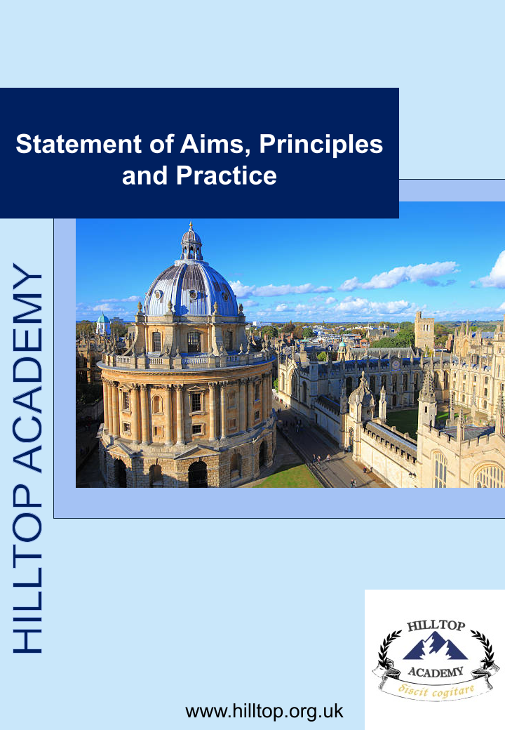

Contents

Contents 2
Hilltop Guardianship Organisation 3
Statement of Aims, Principles and Practice (Standard 1.1) 3
Aims 4
Principles 4
Practice 4

Hilltop Guardianship Organisation

Statement of Aims, Principles and Practice (Standard 1.1)
This statement, publicly available on our website, outlines the aims, guiding principles, and practices of Hilltop Guardianship Organisation, in accordance with AEGIS Quality Standard 1.1. It reflects our commitment to safeguarding, transparency, and high-quality care for international students under our guardianship.

Aims
• To ensure that all international students in our care are safe, supported, and empowered to thrive both academically and personally.
• To work in partnership with parents, schools, and homestays to provide seamless guardianship support.
• To maintain the highest standards of safeguarding and welfare in line with UK legislation and AEGIS requirements.
• To offer clear communication, accurate information, and realistic expectations to parents, students, and partners.

Principles
• Safeguarding First – The welfare, safety, and wellbeing of students is our highest priority.
• Transparency – All information provided by Hilltop is clear, accurate, and accessible.
• Inclusivity – We respect the rights, cultures, and beliefs of all students and their families.
• Accountability – We operate with professionalism, integrity, and accountability at all times.
• Partnership – We foster strong, collaborative relationships with schools, homestays, and parents.

Practice
• Safeguarding: Hilltop implements robust safeguarding policies in line with statutory guidance ('Keeping Children Safe in Education' and 'Working Together to Safeguard Children').
• Support: We provide 24/7 emergency contact for students and families, ensuring round-the-clock availability.
• Homestay Care: All homestay families undergo safer recruitment checks, training, and annual monitoring.
• Communication: Parents receive regular updates on student welfare, academic progress, and any concerns.
• Emergency Arrangements: Hilltop ensures contingency planning for homestay, travel, or health emergencies.
• Professional Standards: All staff, coordinators, and homestays receive induction, safeguarding training, and follow Hilltop’s Code of Conduct.
This Statement of Aims, Principles and Practice is publicly available and reviewed annually to ensure compliance with AEGIS Quality Standards and evolving safeguarding requirements.

